Cornwall Reads! | Because of Winn-Dixie  by Kate DiCamillo
 | January 2018
Sunday | Monday | Tuesday | Wednesday | Thursday | Friday | Saturday
 | 1 | 2 | 3 | 4 | 5 | 6
 | No School |  |  |  | Kick Off Assembly!  Chapter 1-2 | Students bring  a photo of their family pet on Monday! *
7 | 8 | 9 | 10 | 11 | 12 | 13
 | Chapters 3-4 | Chapter 5 | Chapter 6 | Chapter 7 | Chapter 8-9 | Bring your favorite stuffed dog or animal to school January 17th!
14 | 15 | 16 | 17 | 18 | 19 | 20
 | Chapter 10  No School | Chapter 11-12 | Chapter 13  Bring stuffed animals! | Chapter 14  KPETS Assembly! | Chapter 15-16  No School | Next week, bring your “Coins for KPETS” service dogs donations!
21 | 22 | 23 | 24 | 25 | 26 | 27
 | Chapter 17  Bring pennies for KPETS! | Chapter 18  Bring pennies for KPETS! | Chapter 19  Bring pennies for KPETS! | Chapter 20  Bring pennies for KPETS! | Chapter 21-22  Bring silver coins for KPETS!
28 | 29 | 30 | 31 | February 1 | February 2  Final Trivia Questions | *Digital pictures can be sent to:
 | Chapter 23 | Chapter 24 | Chapter 25 | Chapter 26  Cornwall’s Because of Winn-Dixie Picnic | Wrap Up Assembly  Movie Night | cornwallelementary@clsd.k12.pa.us.
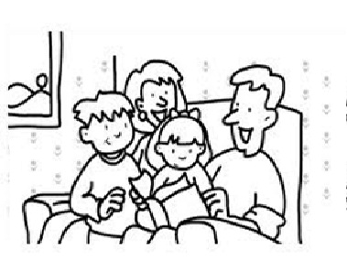
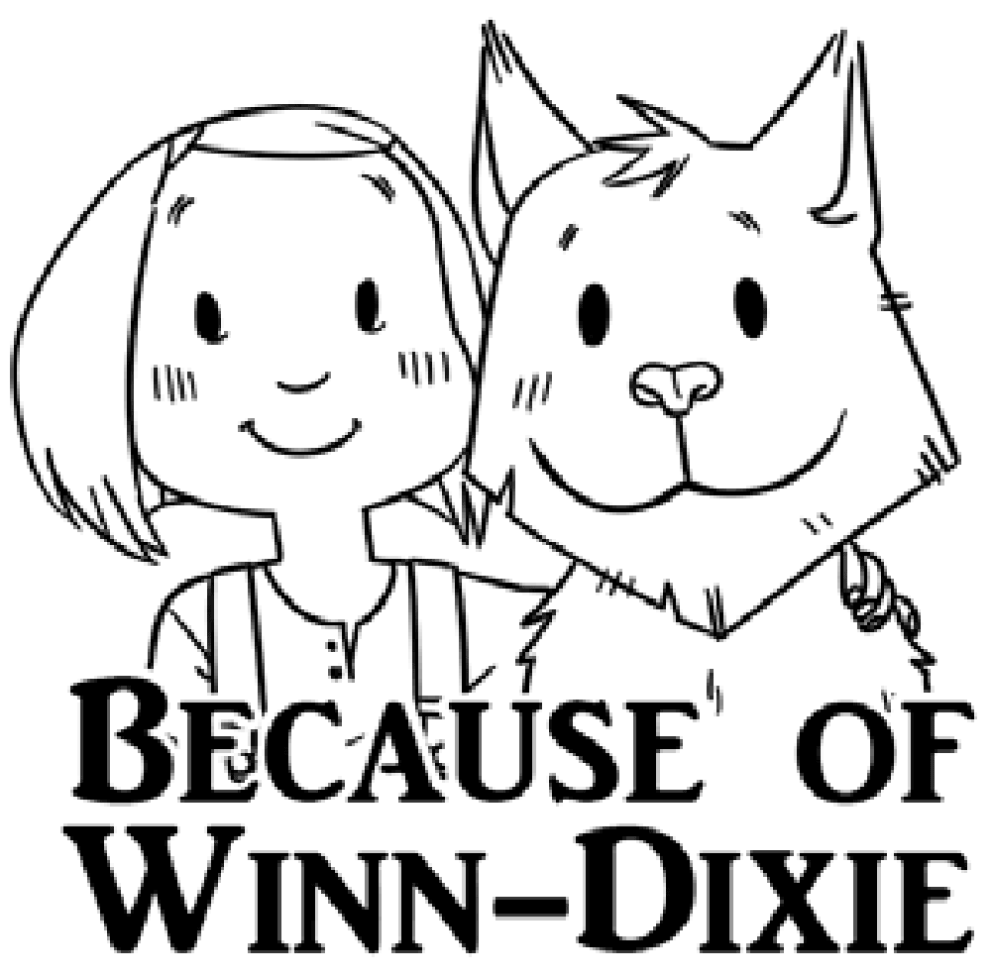
Family Reading Schedule

